Key topics:
- IAC
- IAC Vs Config Management
- Key concepts: Plan, apply, Destroy, import
- Variables and outputs
- Modules
Terraform is Cloud agnostic- Can deploy to all cloud providers. Done through Terraform Registry.
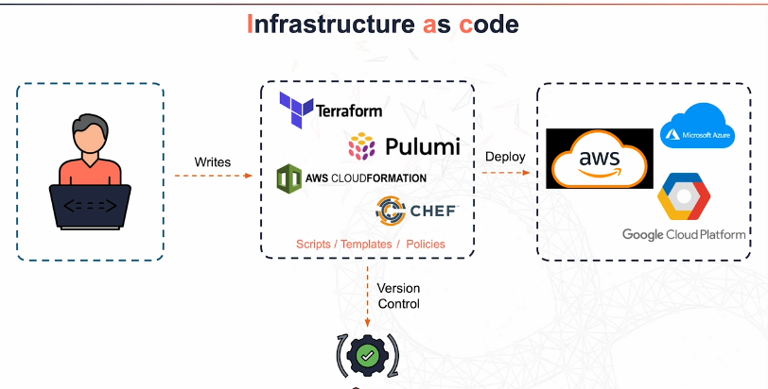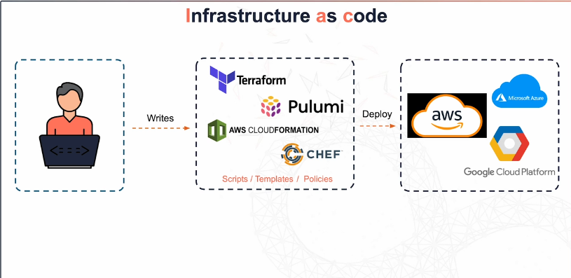
-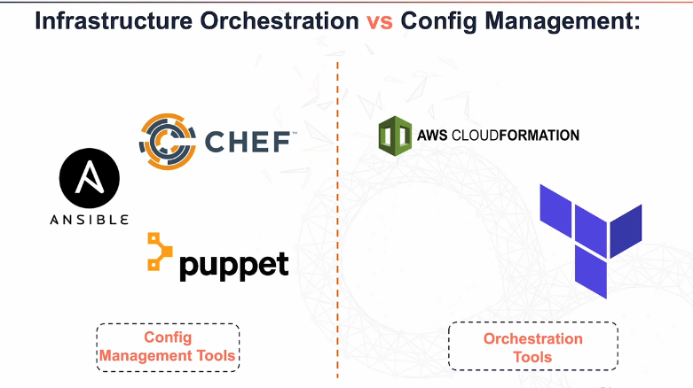
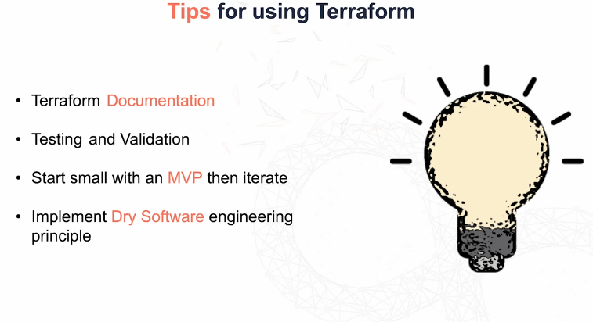
Terraform State File:
- The BLUEPRINT!
- Record of your existing infrastructure
- Ensures idempotency= No matter how many times we run a Terraform configuration, the result will stay the same. Any changes made, it will only apply the change and not rewrite the whole configuration.
Desired vs Current state
- Current state is how your infrastructure is currently and your up to date record. .tfstate
- Desired state is changes you are trying to implement. Compares with your current infrastructure. Compares changes here with the current state so they match. Desired state= what you want to achieve. .tf
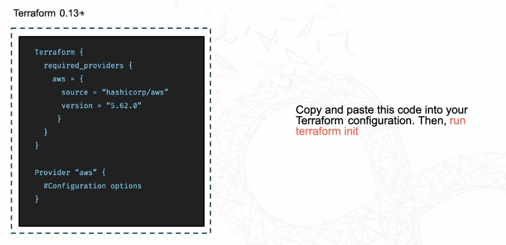
Terraform init (initialize)
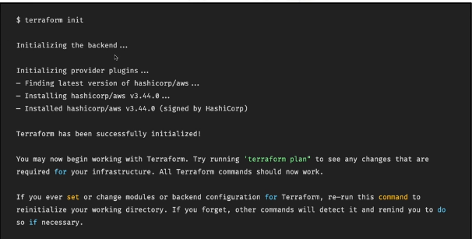
- Initializes the backend, the provider and allows you to use Terraform to run services on your infrastructure.
Terraform plan
- Your way to see what your changes will look like.
- Analyses configuration files, Compares to the current state and then generates a plan.
-
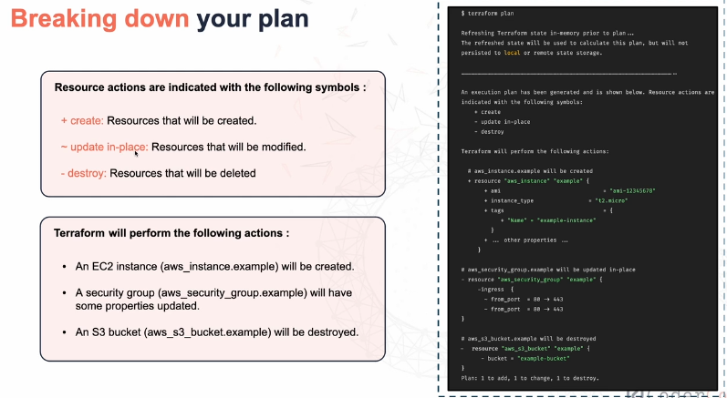
Terraform apply
-Takes the execution plan through Terraform plan and applies it to your infrastructure.
Terraform destroy
-Destroys all remote objects in a particular Terraform configuration
-Creates a destruction plan which details what resources will be destroyed. Will prompt to confirm to avoid accidentally deleting anything.
-Updates the state file to show the resources have been destroyed.
Resource block
- Defines a piece of infrastructure you want to manage i.e an EC2 instance, S3 bucket etc.
-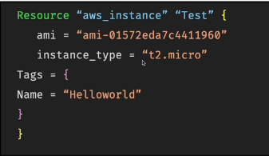
Terraform importing
-Takes existing cloud services that were created under Terraform.
-Important for production environments. Efficient way to practice best practices and to avoid manually deleting and re-creating resources.
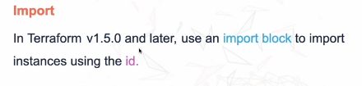
Resource block that is created should match current state. No changes should be made and should be confirmed after running a terraform plan.
Local Statefile
-Terraform stores the statefile locally.
-Easy to set up
- No additional config required
- Ideal for single user projects
Remote statefile
-Stores the state in a central secure location.
-Allows for collaboration.
-State locking to prevent changes.
-Automatic backups and apply encryption.
Backend block
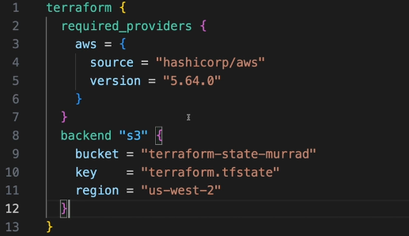
Terraform Workflow
-init: Initializes a working directory containing terraform config files.
-downloads providers
-downloads backend
-Validate: Ensures consistency.
-Plan: Creates an execution plan.
-Determines what actions are necessary to achieve a desired state specified in the configuration files.
-Apply: Applies the changes made to reach the desired state.
-Destroy: Destroys the terraform managed infrastructure.
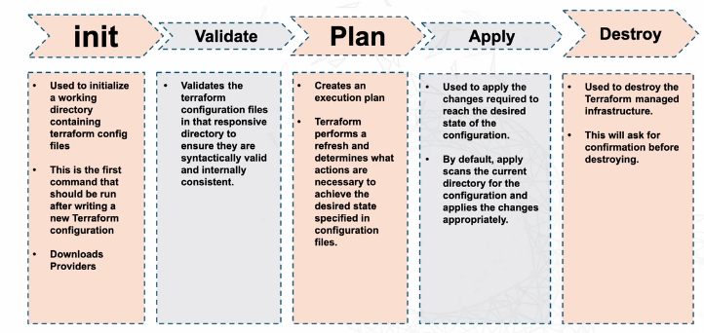
Variables
-Parameterise your configuration.
-Allows to make changes easier
-Allows reusable code
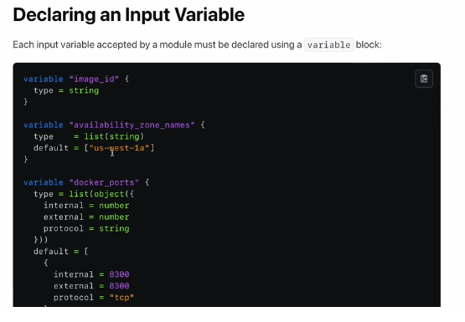
Input Variables- Provided by users.

Local Variables- Store immediate values that can be assigned once and used multiple times. Internal to Terraform config.
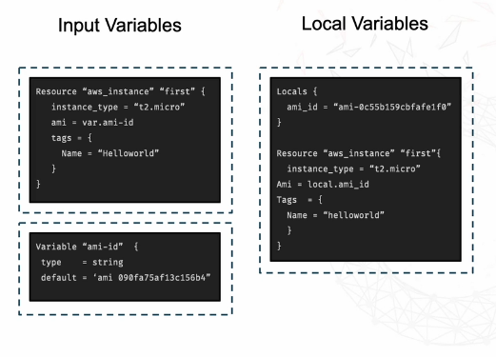
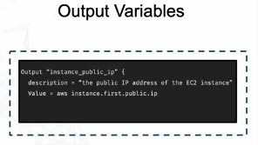
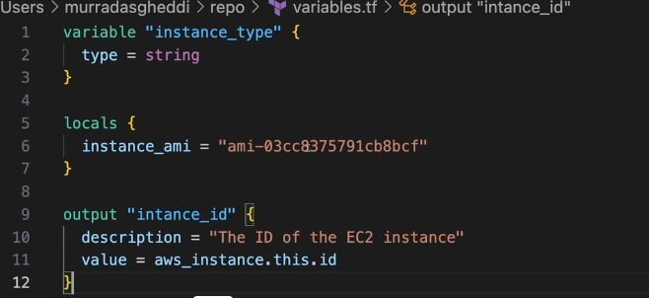
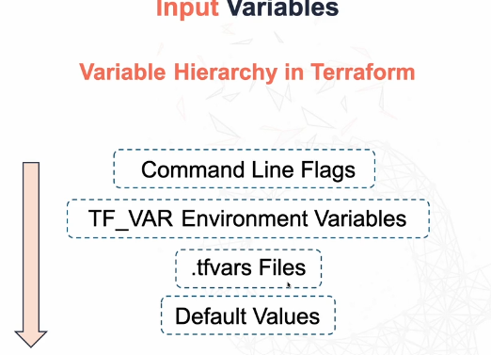
Modules
-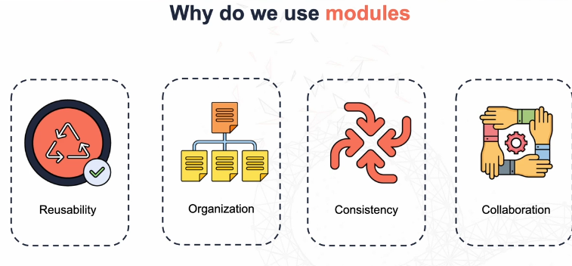
Reusable Infrastructure code to be used for multiple environments/projects. Keeps it dry.
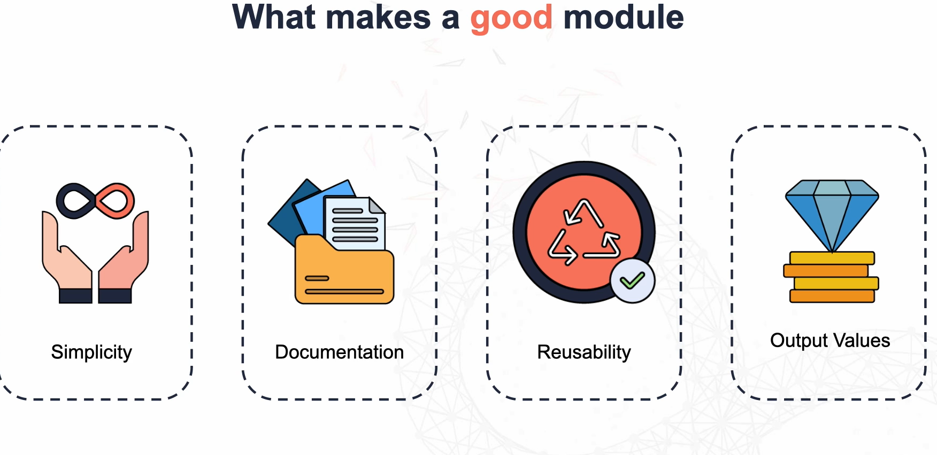
Merging various variables into one
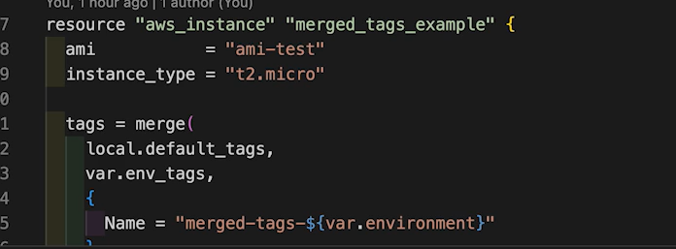
Ranges
